Dear Students,

You don’t have to submit this assignment, but I recommend you to review these questions before your Quiz 2 as a preparation

The Quiz 2 should have up to 4 questions related to these:

Chapter 6 The Little Man Computer

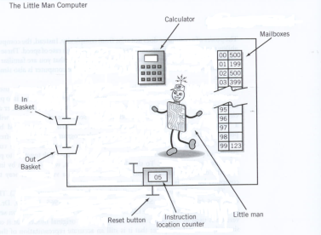Consider this model of the LMC and answer the questions below

*Please refer to this table of op codes for problems 1*

Opcode Definition

0 Halt

1 ADD

2 SUBTRACT

3 STORE

5 LOAD

6 BRANCH UNCONDITIONALLY

7 BRANCH ON ZERO

8 BRANCH ON POSITIVE

901 INPUT

902 OUTPUT

*Please refer to this table of Mailboxes and Contents for problems 1 through 3*

## Mailbox Contents Calculator

00 505 1

01 106 4 << 1 + 3

02 507 6

03 902

04 000

05 1 DAT

06 3 DAT

07 6 DAT

1. What is the value in the **calculator** after the first instruction (505) is completed? **1**

2. What is the value in the **calculator** after the fetch but before the execute portion of second instruction (106)? **1**

3 What is the value in the program counter (instruction location counter) when the program is finished?

a) 03

b) 04

c) 05

**d) 06**

Section 5

The 9’s complementary operation.

a) Find the 9’s complementary representation for the *three*-digit number -451.

**999-451 = 548**

b) Find the 9’s complementary representation for the *four*-digit number -551.

**9999-0551 = 9448**

**Section 5.3 Real Numbers**

In problems 9-13 use the floating point format SEEMMMMM, where S = 0 is "+" and 5 is "-"; EE is the exponent in excess-50, and MMMMM are five digits of mantissa.

Show how 14.25 is represented in SEEMMMMM format.

**05214250**